Chapter 3 Quiz

1. Label the pairs of lines segments as
- parallel or
- perpendicular or
- neither
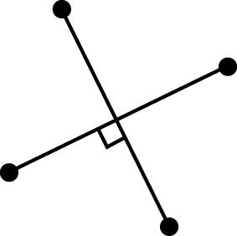  a) | 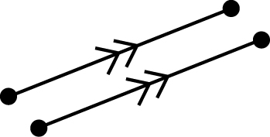  b) | 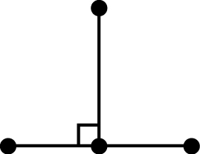  c)
d) | e) | 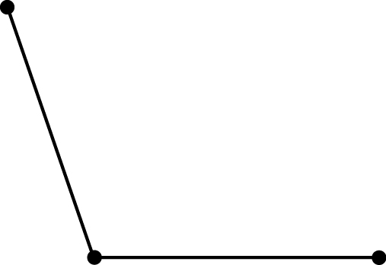  f)

2. Draw a line segment that is 7 cm long. Draw the perpendicular bisector of the line segment.

3. Measure each angle. Write the measure in the blank. Then use a compass, ruler, and pencil to bisect the angles.

a)  __________ | b)  ___________

4. Use your knowledge of the area of a parallelogram to fill in the blanks in the table below.

Base | Height | Area of Parallelogram
a) 5 cm | 3 cm | A = ________(formula)  A = ___ x____  A = _____ cm²
b) 6 cm | 4 cm | A = ____ × ____  A =___________
c) I know the area. I can find the base:  ________ cm | 5 cm | 45 cm²
d) 12 cm | I know the area. I can find the height:  ________ cm | 120 cm²

5. What is the area of each parallelogram? (Show your work)

a) Base = 7 cm and Height = 9 cm

b) Base = 3 m and height = 6.2 m

6. Find the area of the parallelogram below. (Show your work)

